Practical-7
Aim:
Process submitted registration/contact form data using PHP. Validate and
sanitize inputs on the server side and store records in CSV or JSON file
format. Display success/error messages.
Screenshots:
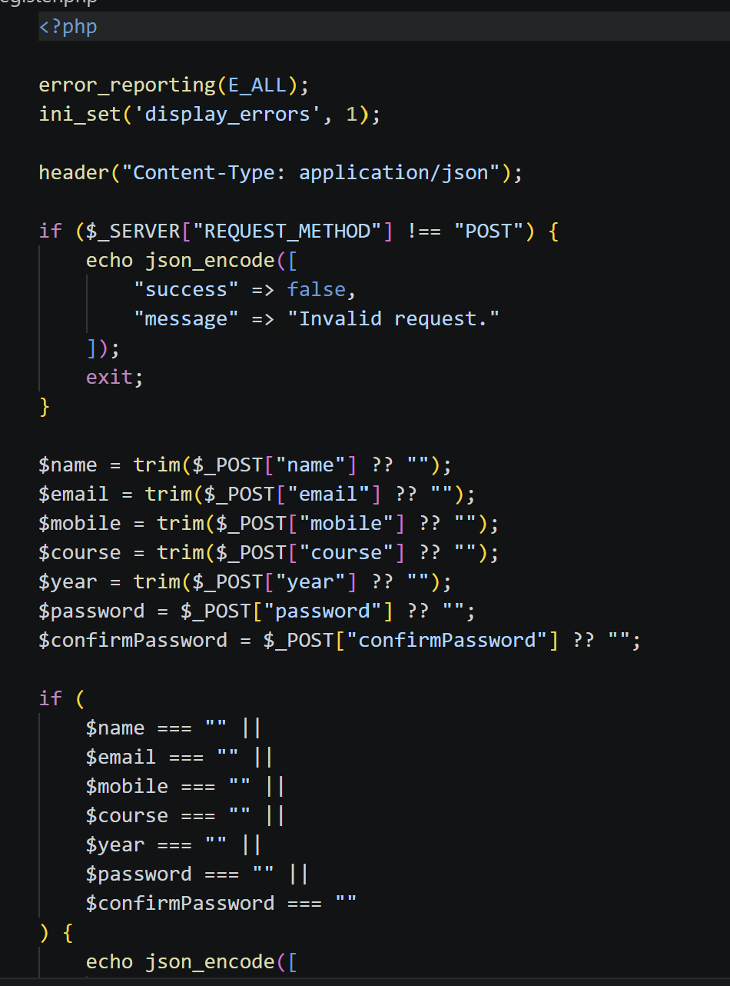

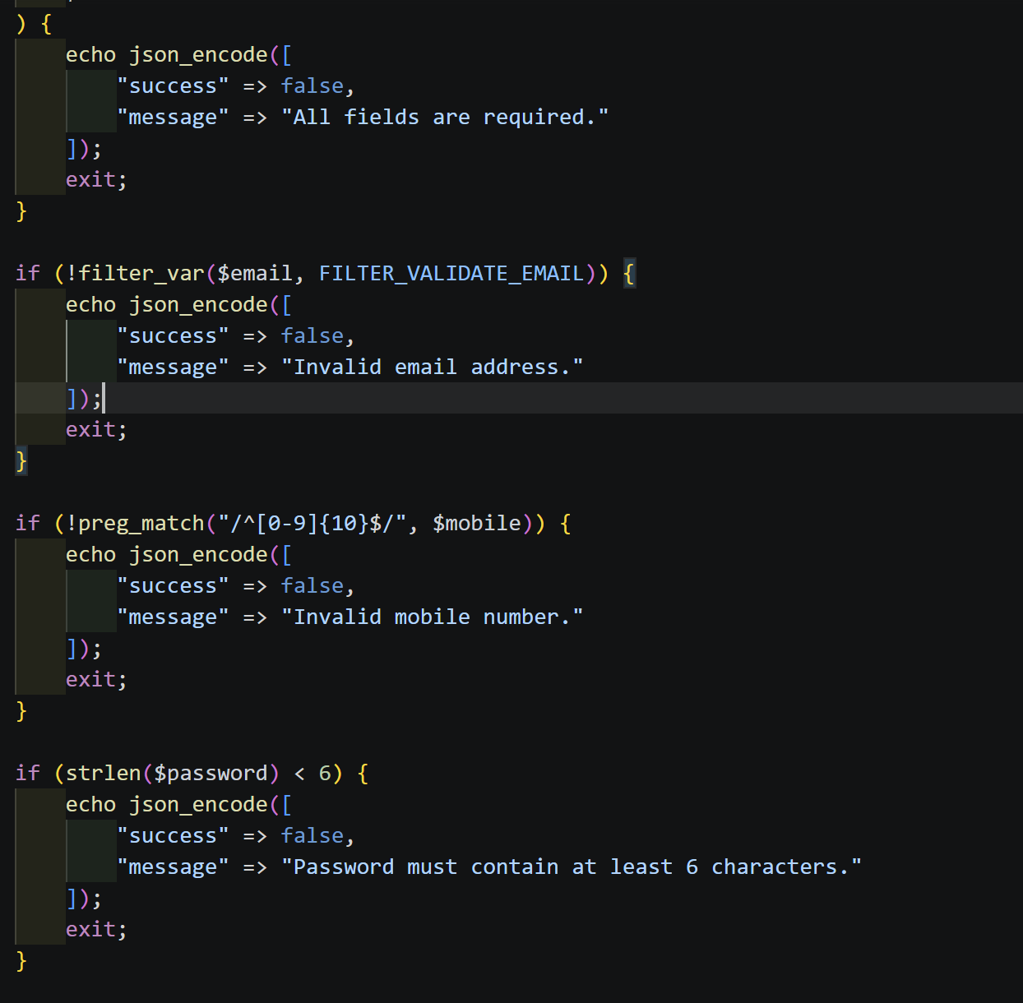

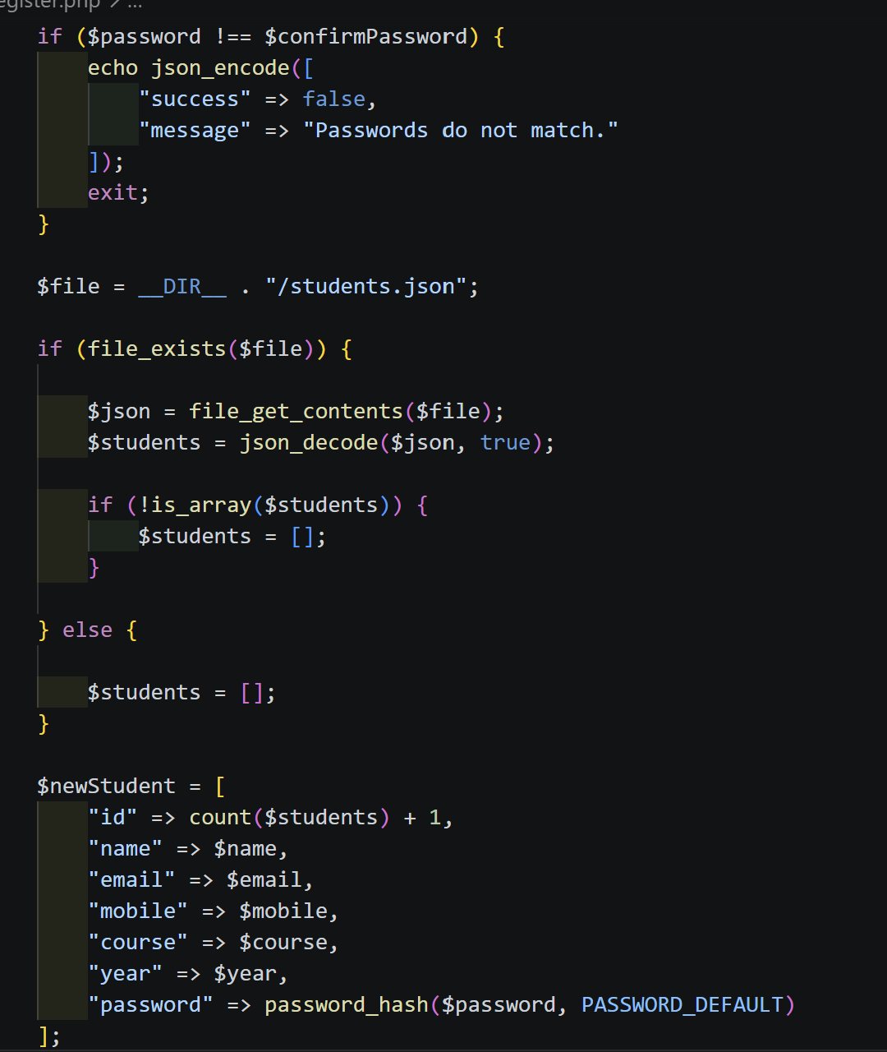

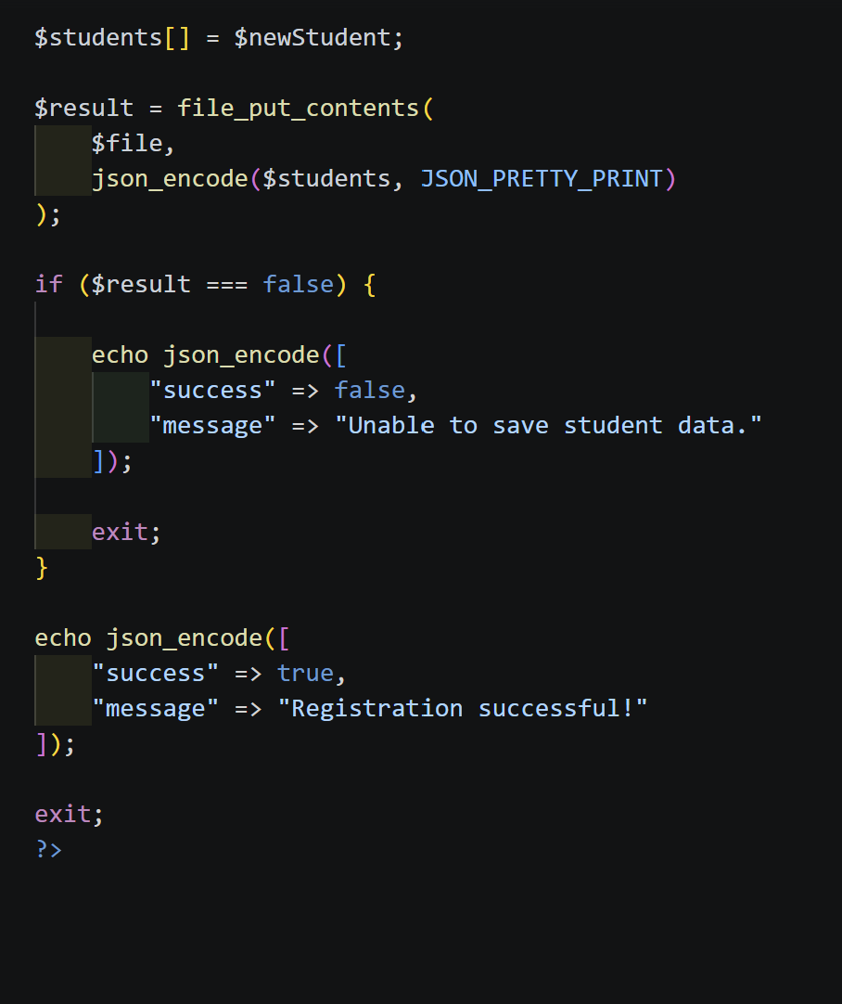

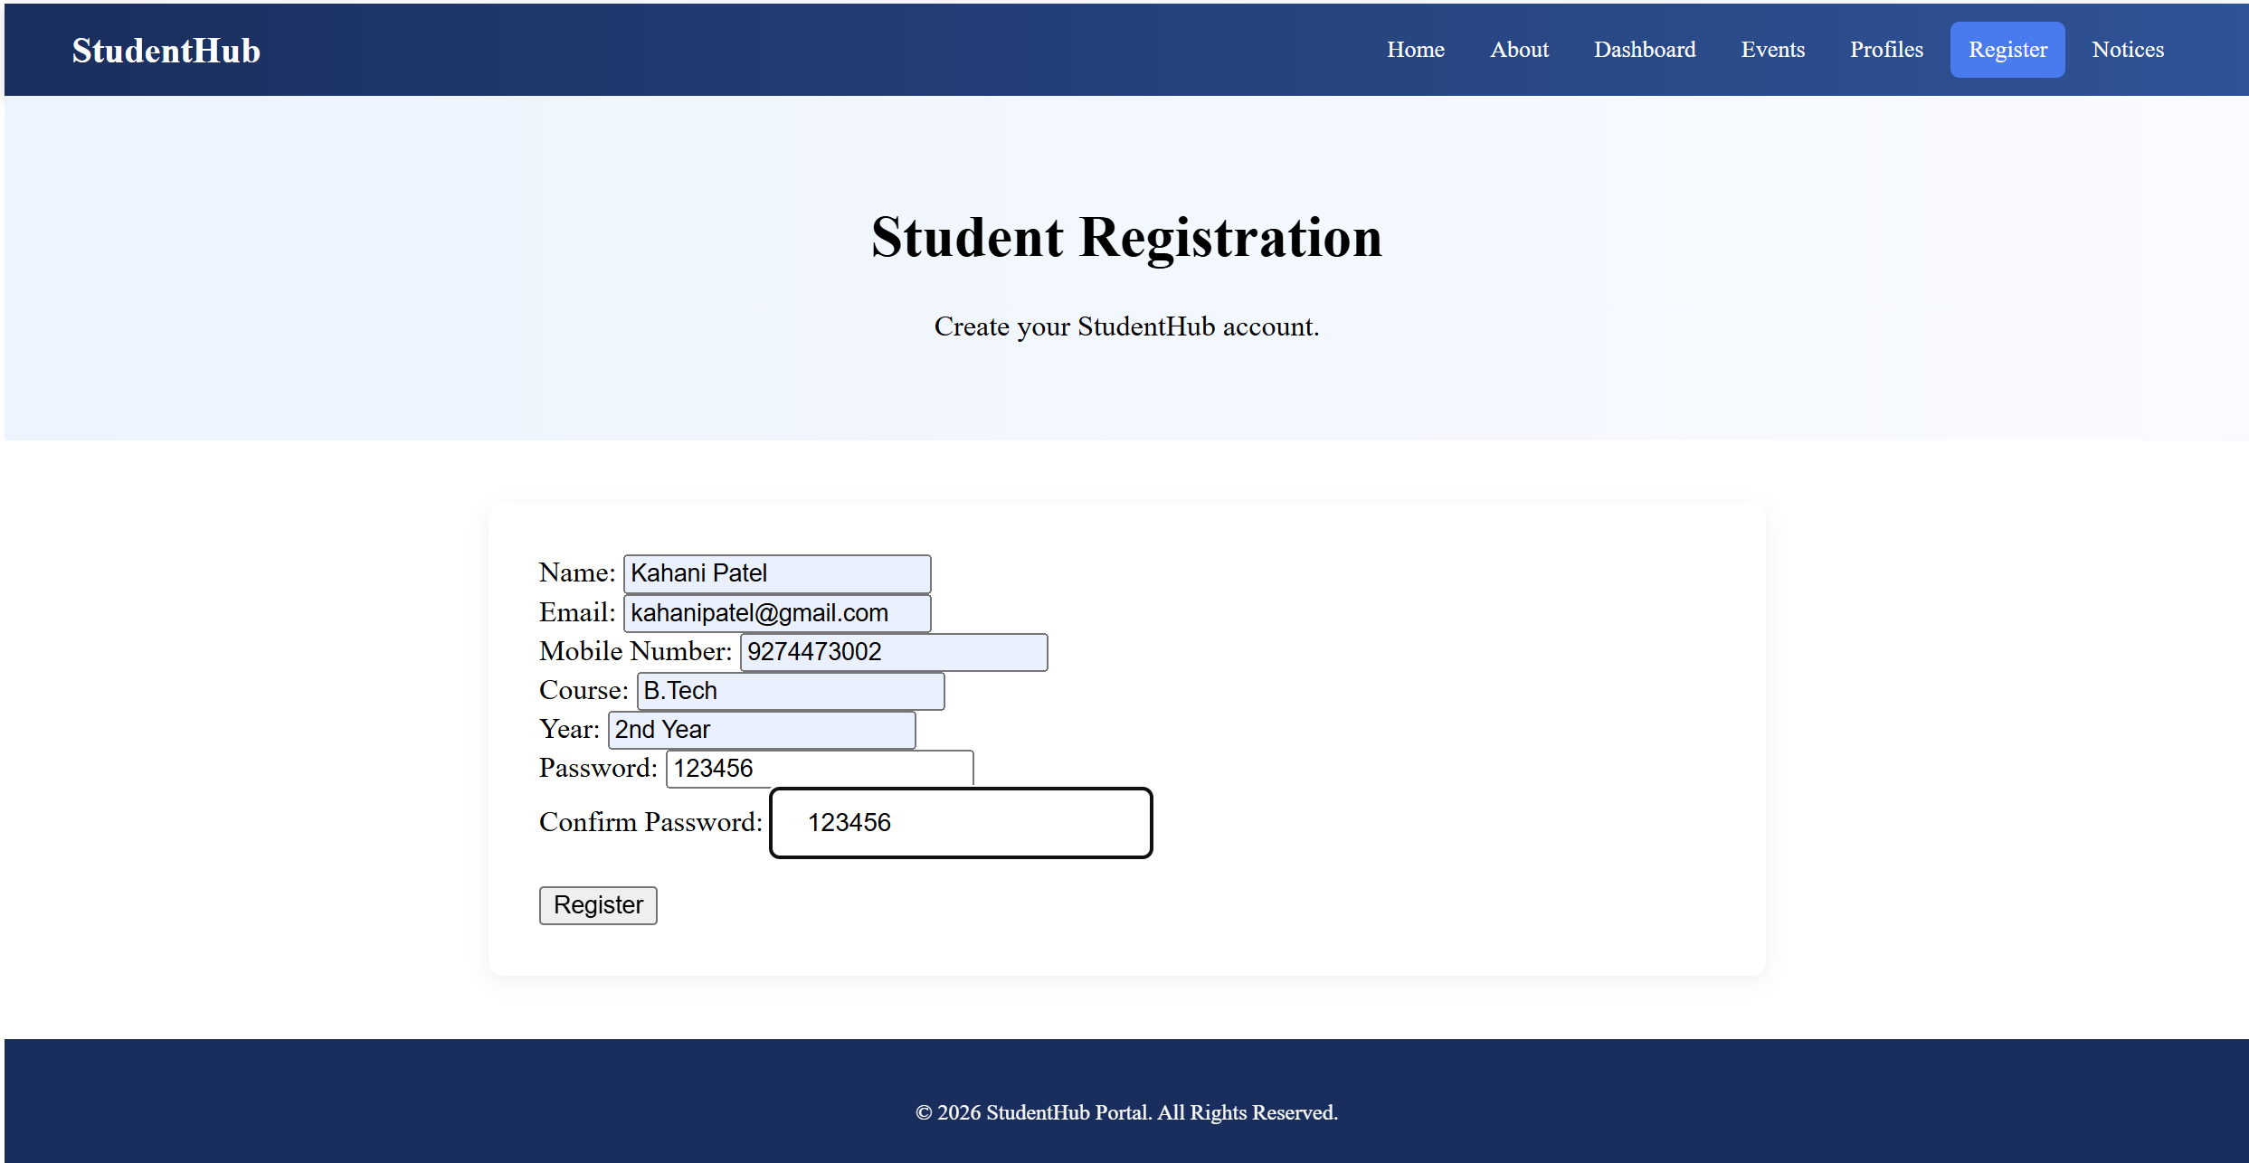
After clicking to register button dashboard is opeaned.
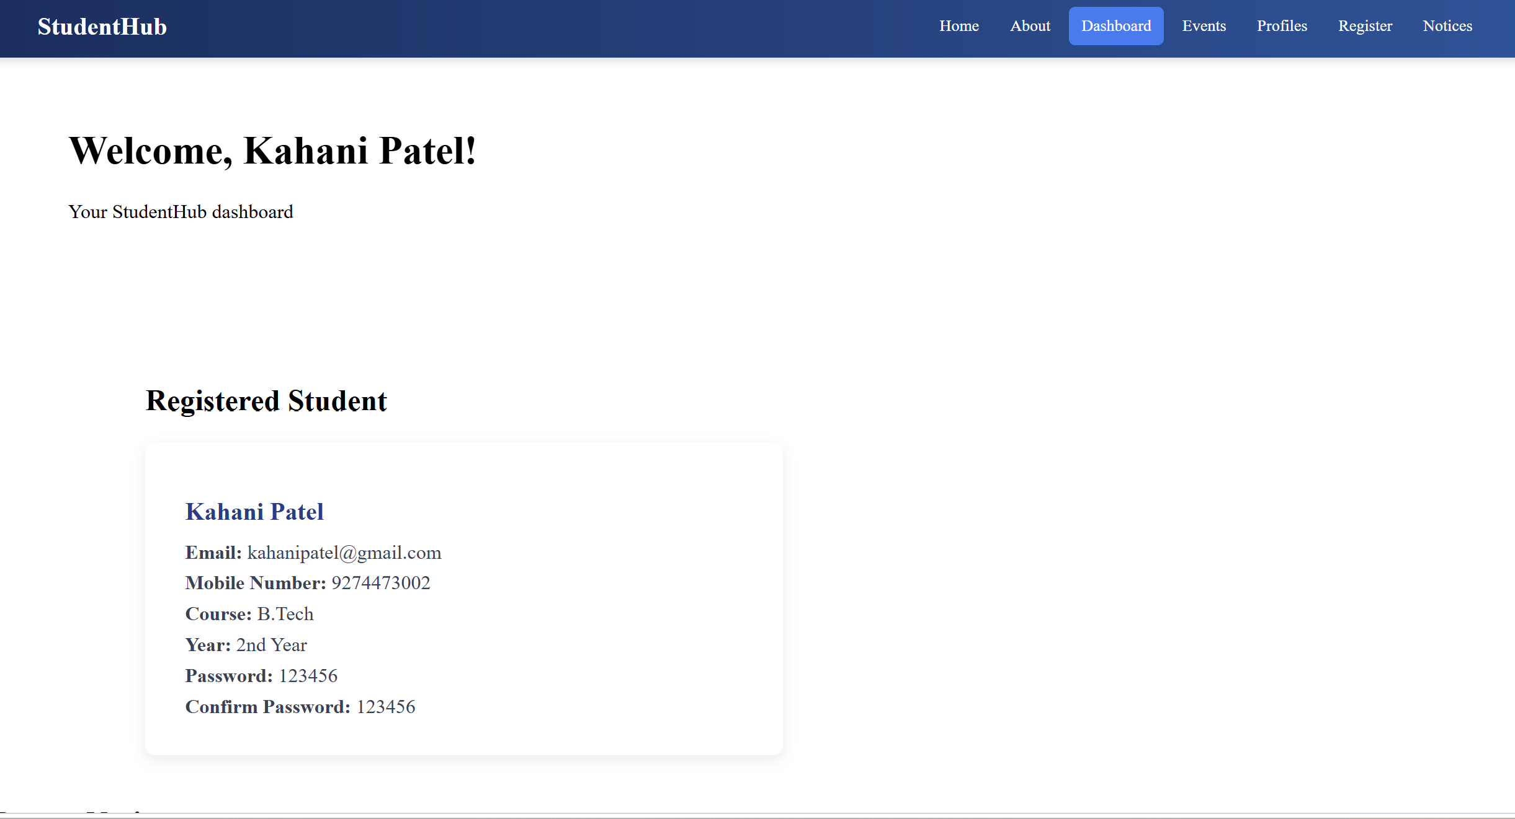

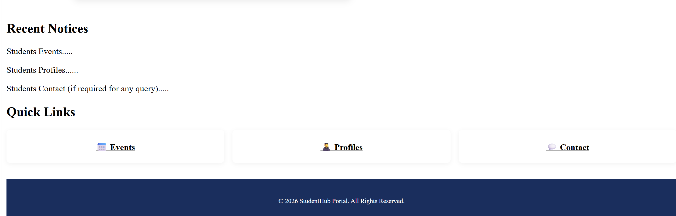
Learning:
Concept of php in webpages.

